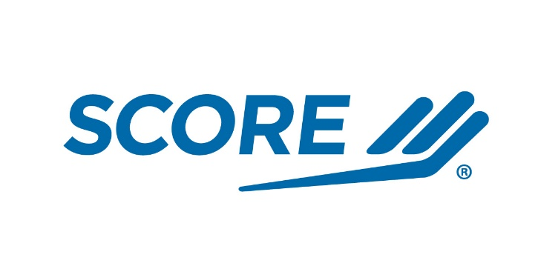

Date

Billing Contact
Billing Address

Sent VIA Email: Email Address

Allocate funds to:
Chapter Name

INVOICE #ADD NUMBER

Put description here $AMOUNT

Balance Due: $ AMOUNT

Make checks payable to:
SCORE Chapter Name
Chapter Address

.

Service Corps of Retired Executives Association
DBA The SCORE Association is a 501(c)(3) national non-profit organization
EIN # - 52-1067290

